# DAD 220 Module Five Major Activity Template

## Overview

Review the scenario for this activity in the guidelines and rubric. Then complete the steps below as you work through the directions for this activity. Replace the bracketed text with your screenshots and responses to the prompts. Size each screenshot and its explanation to fit approximately one-quarter of the page with the description written below the screenshot. Review the Template Screenshot Example linked in the guidelines and rubric for this assignment to see an example of how screenshots for your assignment should look.

## Create a Database

1. **Write SQL commands** that capture specific, usable data that can be used in your analysis.
   1. **Reference notes for this step:** Import the CSV file into MySQL Table. Use the following line terminators when importing: \r\n. Do not use IGNORE 1 LINES for data that does not have column headers in the first row.
2. **Analyze the results of queries** to identify specific information that can be presented in your summary.
   1. Sales by region:
      1. Analyze sales data by state to determine where the company has the largest customer base.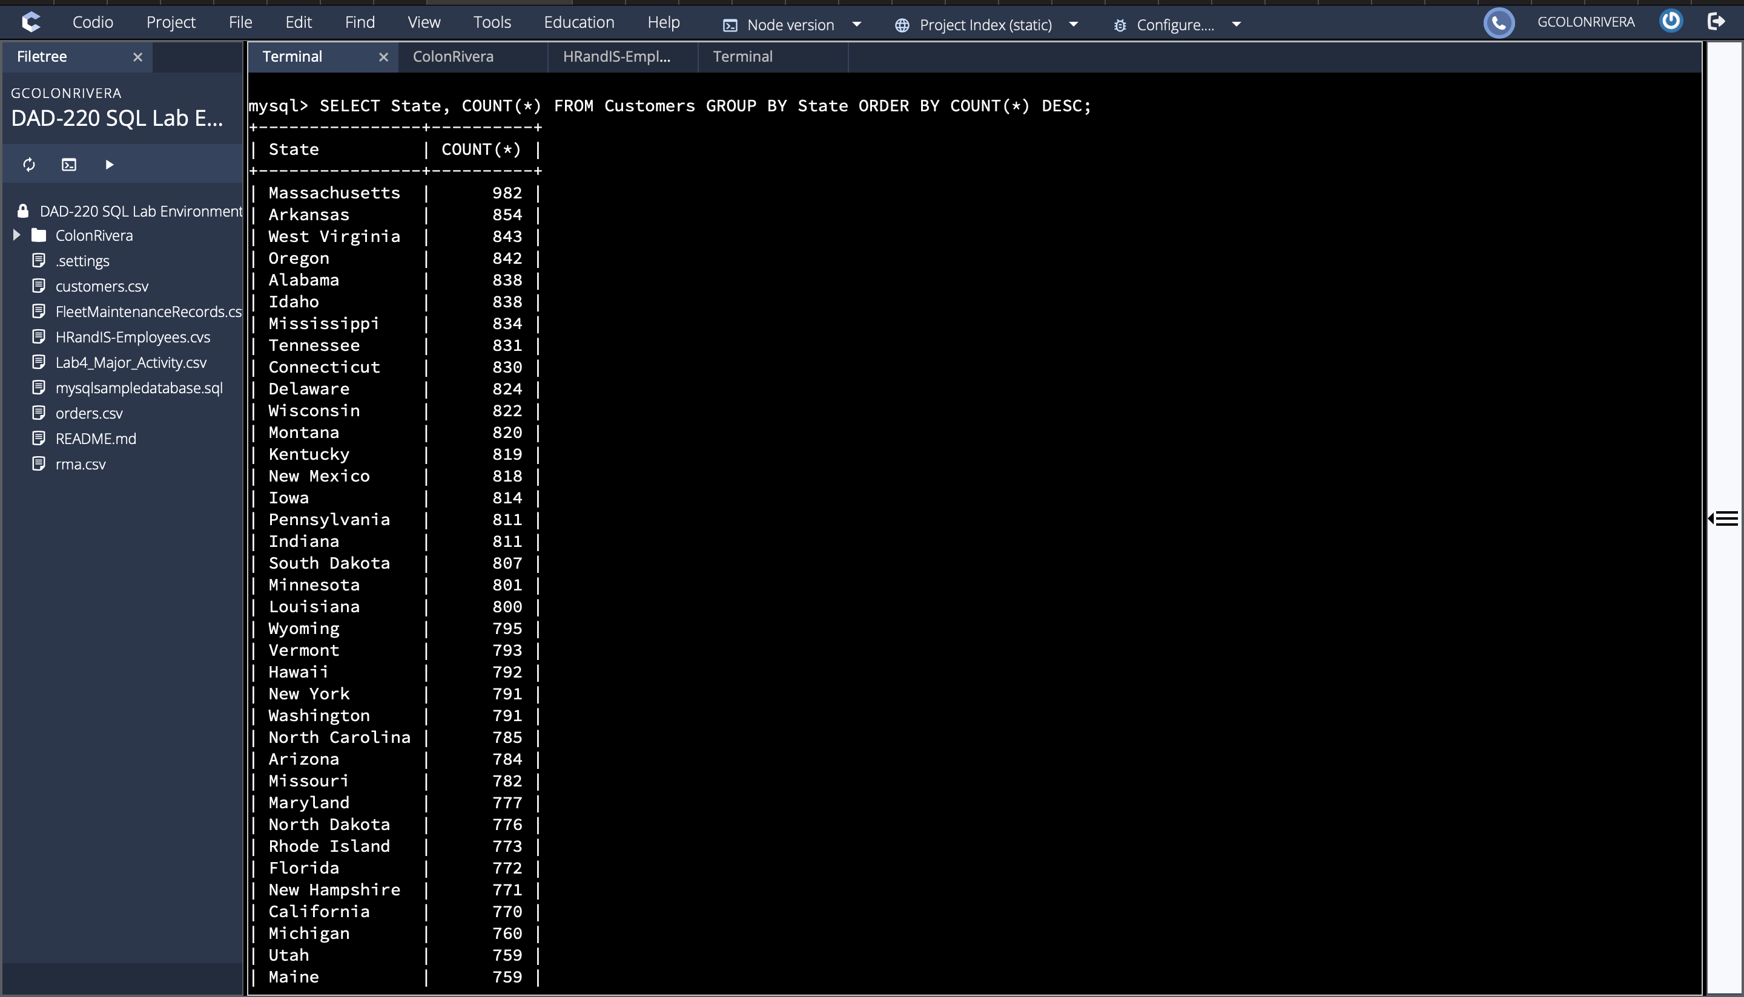

Massachusetts has the largest customer total at 982.

* + 1. Analyze the data to determine the top three products sold in the United States.

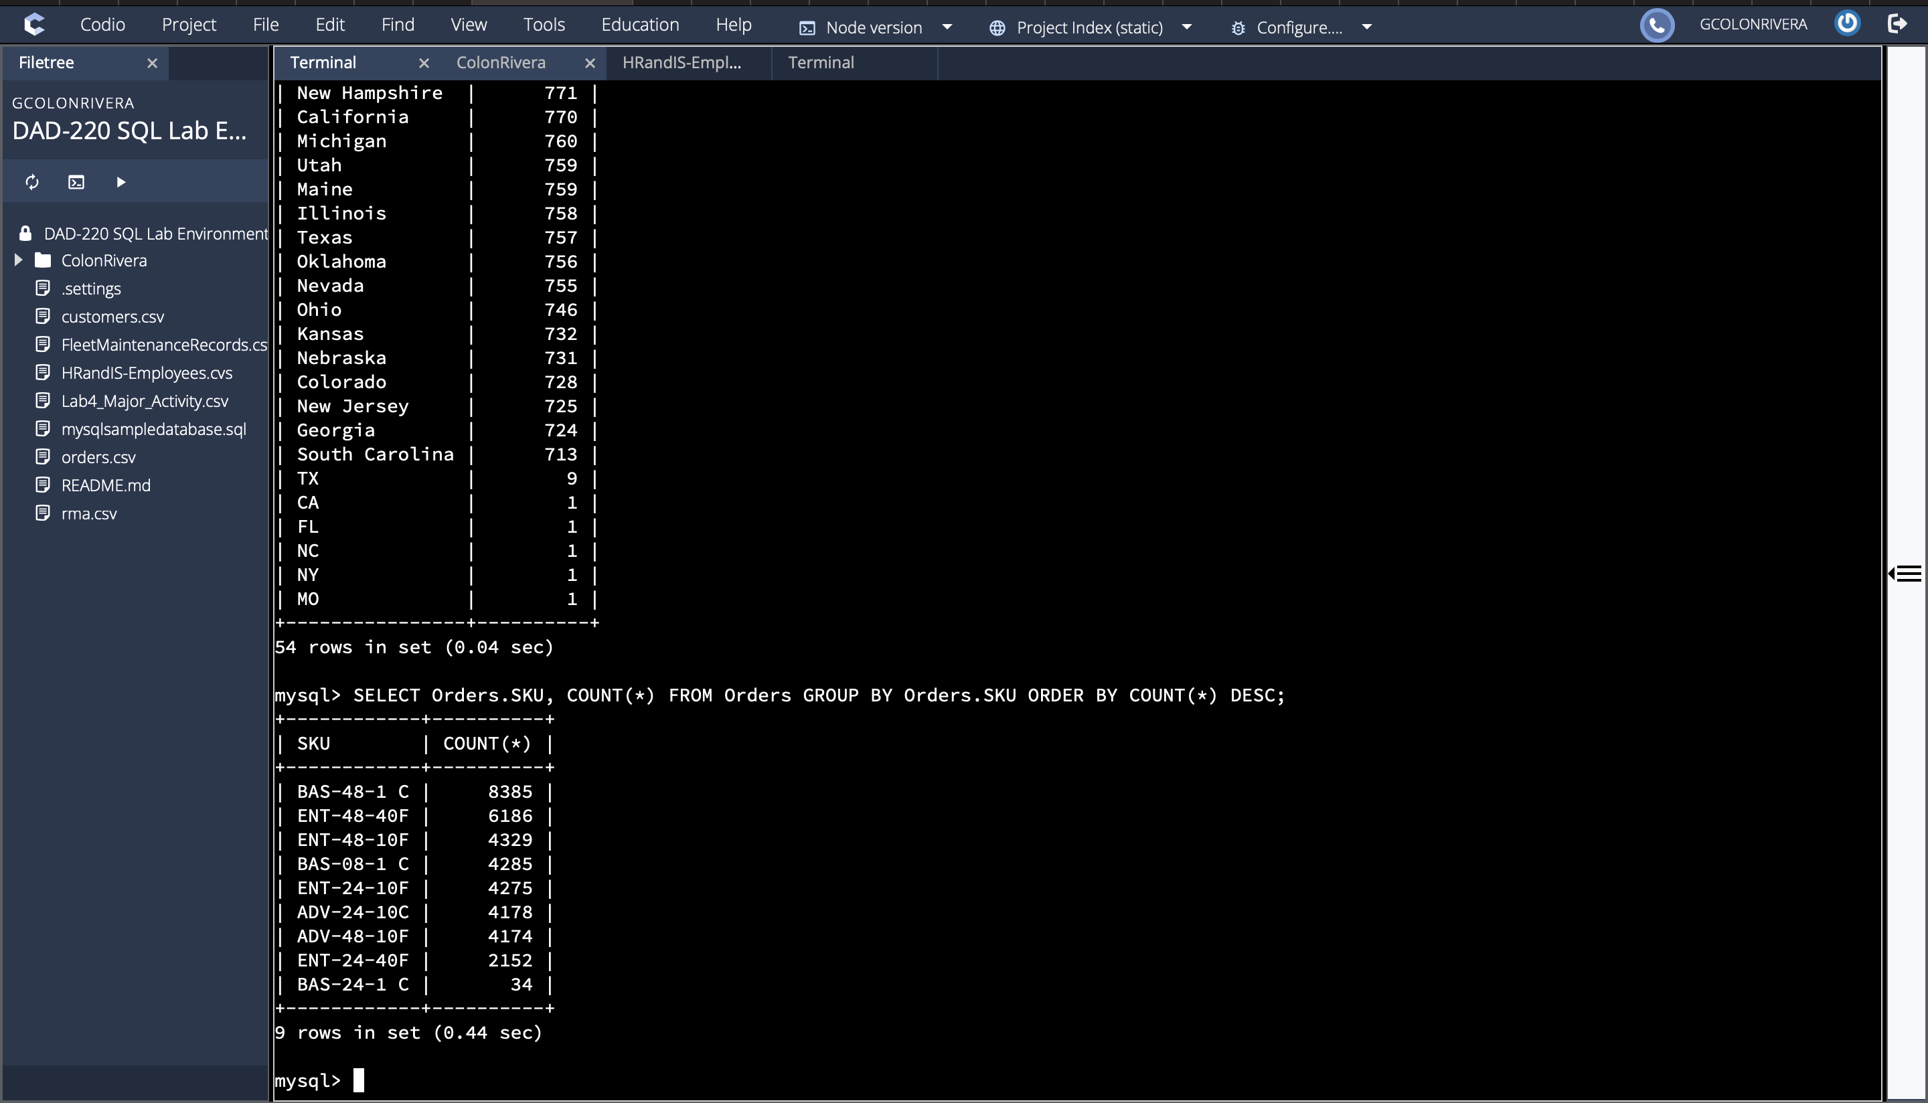

The top 3 products sold in the US are BAS-48-1 C, ENT-48-40F, and ENT-48-10F

* + 1. Analyze the data to determine the top three products sold in the southeastern region of the United States.
* Southeastern states to include in your analysis: Virginia, North Carolina, South Carolina, and Georgia

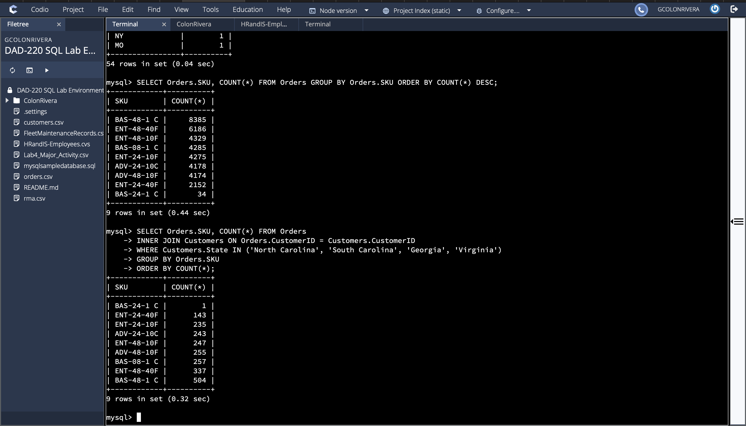

Top 3 products sold in the Southeast of the US are the BAS-48-1 C, the ENT-48-40F and the BAS-08-1 C.

* 1. Returns by region:
     1. Analyze the data to determine the top three products returned in the United States.

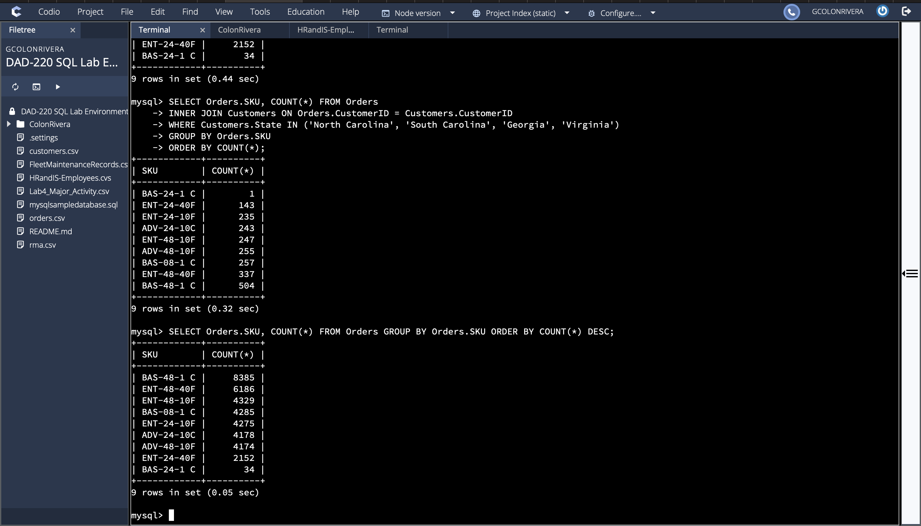

The top 3 products sold in the US are the BAS-48-1 C, the ENT-48-40F, and the ENT-48-10F.

* + 1. Analyze the data to determine the top three products returned in the northwestern region of the United States.
* Northwestern states to include in your analysis: Washington, Oregon, Idaho, and Montana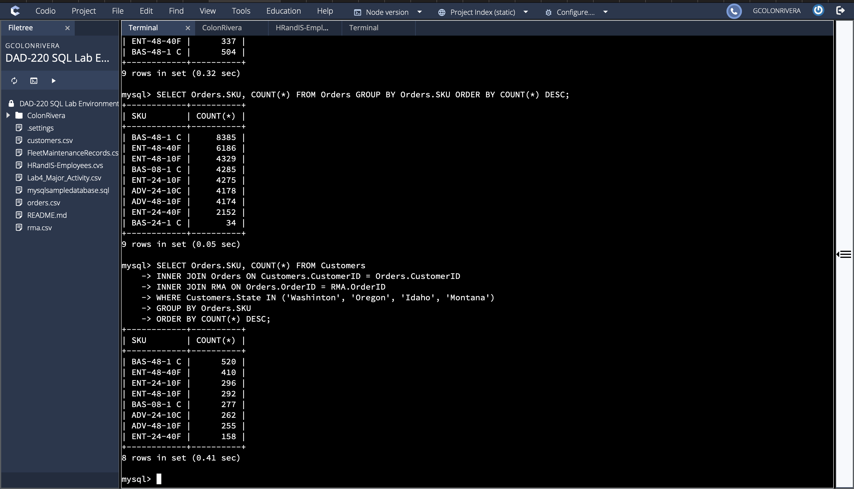

Top 3 projects returned in the Northwest of the US are the BAS-48-1 C, the ENT-48-40F, and the ENT-24-10F.

1. **Write a report** to the Quantigration product manager that explains your findings in a way nontechnical stakeholders can understand and use.
   1. Provide an effective summary of your findings from the analysis of the sales and returns data you captured. Write at least one paragraph for each of your responses to the prompts below.
      1. Sales data by region: Provide a well-written summary of findings from your analysis in Step Two, Part A.

The results of the analysis to learn about the company’s customers. The results reflected that the state with the biggest customer base is Massachusetts with 982 customers. Followed by Arkansas with 854 customers and West Virginia having 843 customers. Another query was used to determine the top three selling products across the country. The results showed that the the main SKU numbers that are most popular are BAS-48-1 C, ENT-48-40F, and ENT-48-10F. Another query was used to further look at the top three products sold in the Southeast region of the US, which included Virginia, North Carolina, South Carolina, and Georgia. The results showed that these SKU numbers are the most popular in these states BAS-48-1C, ENT-48-40F, and BAS-08-1C. These results allow the company’s stakeholders to monitor current trends and determine any common factor between the top products sold across the country.

* + 1. Returns data by region: Provide a well-written summary of findings from your analysis in Step Two, Part B.

These queries were not only used to look at the top-selling products, but a couple of queries were also used to look at the top products being RMA’d by customers. After running a query, it was determined the top three products returned in the US are SKU numbers are the most popular BAS-48-1C with 8282 returns, ENT-48-40F with 6118 returns, and ENT-48-10F with 4287 returns. We looked at a specific region, in this case, The northwest region of the US, including Washington, Oregon, Idaho, and Montana. The top three products returned in this region are the SKU numbers BAS-48-1 C, ENT-48-40F, and BAS-08-1 C. The results that were returned were troubling because the most popular product, BAS-48-1C, is also the top product being RMA’D. The company needs to look into this product to determine if quality needs to be improved to offer a more reliable product and decrease the RMAs of the same product.